SCHOOL OF MATERIALS SCIENCE & ENGINEERING

CONTINUOUS ASSESSMENT 1 SEMESTER 1 2024-2025

MS1016 – THERMODYNAMICS OF MATERIALS

(Answer Sheet)

25 September 2024 Time Allowed: 1 hour

INSTRUCTIONS

1. This paper contains THREE (3) short questions and TEN (10) MCQ questions.

2. Answer ALL questions.

3. Write all answers on the answer sheet provided and clearly write your name and matriculation number on it.

4. This is an open-notes test.

5. All questions have ONLY ONE correct answer for the MCQ questions.

6. You may retain this question sheet. Only answers on the submitted answer sheet will be considered.

PART I – SHORT QUESTIONS
- After vanquishing Voldemort and restoring peace to the Wizarding World, Harry Potter decides to embark on a new academic journey at NTU. In Prof. Leonardo’s class on thermodynamics, Harry learns that the mysteries of magic and science are not so different after all. Fascinated by how energy moves and changes within magical artifacts, Harry seeks to develop a new spell—"Energeum Regulatus"—designed to manipulate the Gibbs free energy of powerful magical objects, like his own wand. However, before he can perfect the spell, Harry must first derive a key thermodynamic relationship using the power of this equation.
- Help Harry master his spell, Energeum Regulatus, by deriving the relationship:
$$dG=VdP-SdT$$
and prove one of the thermodynamic Maxwell relations that Dumbledore himself would be proud of. Through this derivation, Harry will gain the final insight needed to fully control the Gibbs free energy of his wand and cast Energeum Regulatus to its fullest potential.
(10 Marks)

- Now that Harry has mastered the Maxwell relation, he applies Energeum Regulatus to heat 500 mL of water to prepare his favourite Nongshim noodles. To do this, he needs to heat up water from room temperature (25°C) to boiling point (100°C) at constant pressure (1 atm).
To help Harry, derive the change in entropy ΔS from the relation of heat δ$Q=mC_{p} dT$, and use it to calculate the change in entropy during the heating process.

Given:
- Mass of water: 500 g (0.5 kg)
- Initial temperature, $T_{i}$ : 25°C = 298.15 K
- Final temperature, $T_{f}$ : 100°C = 373.15 K
- C_{p}​ for water = 4.18 J/g·°C = 4180 J/kg·K

Derive and use the formula:
$$ΔS=\int_{T_{i}}^{T_{f}}{\frac{{m.c}_{p}}{T}}dT$$

[Hint: You do not need to use your previously derived Maxwell relation in (a).]

(10 marks)
- Given $G=H-TS$
$dG=dH-TdS-SdT$ (1 marks)
From Enthalpy (H) equation, $H=U+PV,$ $dH=dU+PdV+VdP$ (1 marks)
From the first law, $dU=δQ-PdV$ and the second law $δQ=TdS$ (2 marks)
Substituting, $dH=TdS-PdV+PdV+VdP=TdS+VdP$ (1 marks)
Therefore, $dG=dH-TdS-SdT=TdS+VdP-TdS-SdT$
$dG=VdP-SdT$ (0.5 mark)
Representing the G in terms of P and T:
$$G=G(P,T)$$
$dG={(\frac{∂G}{∂P})}_{T}dP+{(\frac{∂G}{∂T})}_{p}dT$ (1 marks)
Therefore, ${(\frac{∂G}{∂P})}_{T}=V$; and ${(\frac{∂G}{∂T})}_{p}=-S$ (0.5 mark)
Find the cross derivatives,
${(\frac{∂V}{∂T})}_{P}= {{[\frac{∂}{∂T} (\frac{∂G}{∂P})}_{T}]}_{P}= \frac{∂^{2}G}{∂T∂P}$, and $- {\left(\frac{∂S}{∂P}\right)}_{T}= -{{[\frac{∂}{∂P} (\frac{∂G}{∂T})}_{P}]}_{T}= -\frac{∂^{2}G}{∂P∂T}$ (2 marks)
For exact differentials, the cross derivatives are equal,
$\frac{∂^{2}G}{∂T∂P}=\frac{∂^{2}G}{∂P∂T}$ (0.5 mark)

Hence, $-{(\frac{∂V}{∂T})}_{P}= {\left(\frac{∂S}{∂P}\right)}_{T}$ (0.5 mark)

- Now, to calculate the change in entropy as Harry heats the water, we start with the specific heat capacity at constant pressure:
$$dQ=m⋅cp​⋅dT$$
The change in entropy is defined as:
$$dS=\frac{dQ}{T}$$
(1 mark)
Substituting into $dQ=m⋅cp⋅dT$ we get:
$$dS=\frac{m⋅c_{p}⋅dT}{T}​$$
(2 marks)
To find the total change in entropy over the temperature range from $T_{i}​$ to $T_{f},$ we integrate:
$$ΔS=\int_{T_{i}}^{T_{f}}{\frac{m⋅c_{p}⋅dT}{T}}$$
$​$ (2 marks)
Since the mass m and specific heat capacity​ are constants, they can be factored out:
$$ΔS=m⋅c_{p}⋅\int_{T_{i}}^{T_{f}}{\frac{1}{T}}dT$$
(1 mark)
This integral gives:
$$ΔS=m⋅c_{p}⋅\ln\left(\frac{T_{f}}{T_{i}}\right)$$

Now, substitute the known values:
- $m=0.5 kg$
- $cp=4180 J/kg.K$
- $T_{i}=298.15 \text{K}$
- $T_{f}=373.15 \left(100°C\right).$
$$ΔS=0.5×4180×\ln\left(\frac{373.15}{298.15}\right)$$

$$ΔS=0.5×4180×0.224=468.32 \text{J}\text{/}\text{K}$$

(4 marks)

- A blast furnace is a massive industrial structure used primarily for the smelting of iron from its ores. One of the reactions that is occurring inside the furnace is the reduction of Iron (II) Oxide (FeO) by Carbon monoxide (CO) to produce iron (Fe) and carbon dioxide (CO₂).

  - Write the chemical equation for the reduction of iron (II) oxide. (2 marks)
FeO + CO → Fe + CO₂

  - Calculate the entropy change for the chemical reaction in standard conditions. Write your workings clearly, omission of steps will result in a loss of marks (4 marks)
Element/Compound | Standard Entropy (J/mol·K)
FeO | 53.97
CO | 197.9
CO₂ | 213.63
Fe | 27.16

FeO + CO →Fe + CO₂

Fe + CO₂ – FeO – CO

ΔS_{r,298} = 27.16 + 213.63 – 53.97 – 197.9
= -11.08 J/mol.K

  - State the concept of the second law of thermodynamics and how it relates to the entropy change calculated in part (b). Also, provide any insights to the value obtained in part (b). (5 marks)
The second law of thermodynamics state that for a spontaneous event to take place, it must be accompanied by an increase in the entropy. (2 marks)

In part b, the entropy change calculated is negative, indicating that the products have lower entropy values compared to the reactants. (1 mark)

This suggests that the products are less disordered than the reactants. (1 mark)

As a result, by the second law of thermodynamics, this reaction is not spontaneous under the given conditions, since it leads to a decrease in entropy. (1 mark)

  - Calculate the entropy change for the chemical reaction at 600K. Write your workings clearly, omission of steps will result in a loss of marks (6 marks)

C_{p} = a + bT + cT⁻² J(mol.K)⁻¹ at 1 atm

Material | a | b x 10⁻³ T
Fe | 37.3 | 6.19
CO₂ | 44.3 | 9.07
FeO | 49.0 | 8.4
CO | 28.3 | 9.12
ΔS_{r,600} = ΔS_{r,298} +

= -11.08 +

= - 11.08 +

= - 11.08 + 4.3 ln - 0.00226[600 – 298]

= - 11.08 + 3.00 – 0.68

= - 8.76 J/ mol.K

  - Explain the effect of irreversible work on the efficiency of real-world systems and its relation to lost work. (3 marks)
The relationship relating reversible work and irreversible work can be modelled as:

$${dS}_{IRREVERSIBLE }= {dS}_{REVERSIBLE }+Lost Work$$

This equation indicates that irreversible work leads to lost work, which reduces the efficiency of real-world systems. The increase in entropy associated with irreversible work represents energy that cannot be converted into useful work, thereby lowering the overall efficiency of the system.

3. Derive the following relations for an ideal gas undergoing an adiabatic process
(i) ${PV}^{γ}$ = constant
(ii)${ TP}^{ \frac{1- γ}{γ} }=constant$
(iii)${ TP}^{- \frac{R }{C_{P}}}=constant$
(iv)${ TV}^{ γ-1}=constant$ (20 marks)

Solution:
For an adiabatic system, $δQ=0$. Applying this condition to the First Law equation,
𝛿W = dU
From the definition of C_{V} (assuming mechanical work),
𝛿W = -PdV
dU = nC_{V}Dt
-PdV = nCvdT (2 marks)
Differentiate the ideal gas law, PV = nRT, to get,
PdV + VdP = nRdT
dT = $\frac{PdV + VdP }{nR}$
Substitute into ,
-PdV = nCv$(\frac{PdV + VdP }{nR})$ (2 marks)
Rearranging,
$\frac{-PdV }{PdV + VdP }$ = $\frac{nCv}{nR}$
Substitute C_{P} - C_{V} = R into
$\frac{-PdV }{PdV + VdP }$ = $\frac{Cv}{C_{P} - C_{V} }$
Taking the reciprocal,
$\frac{PdV + VdP }{-PdV}$ = $\frac{C_{P} - C_{V}}{C_{V} }$
-1 - $\frac{VdP}{PdV}$ = $γ$ – 1
- $\frac{VdP}{PdV}$ = $γ$
Rearranging into a separable equation,
$- \frac{1}{P} dP= γ \frac{1}{V} dV$ (2 marks)Integrating both sides,
$$-\int_{P_{1}}^{P_{2}}{\frac{1}{P} dP}= γ\int_{P_{1}}^{P_{2}}{\frac{1}{V} dV} \\ -ln{(\frac{P_{2}}{P_{1}}})= γ \ln{(\frac{V_{2}}{V_{1}}}) \\ {\ln{(\frac{P_{2}}{P_{1}}})}^{-1}= {\ln{(\frac{V_{2}}{V_{1}}})}^{γ} \\ \ln{(\frac{P_{1}}{P_{2}}})= {\ln{(\frac{V_{2}}{V_{1}}})}^{γ} \\ \left(\frac{P_{1}}{P_{2}}\right)= \left(\frac{{V_{2}}^{γ}}{{V_{1}}^{γ}}\right) \\ P_{1}{V_{1}}^{γ}= P_{2}{V_{2}}^{γ}$$${PV}^{γ}$ = constant [Ans.] (2 marks)
$$\begin{aligned}PV=mRT \\ V=\frac{mRT}{P}\end{aligned}$$
$$P{\left(\frac{RT}{P}\right)}^{γ}=constant$$
$$\frac{P}{P^{γ}}T^{γ}=constant$$
$$P^{1-γ}T^{γ}=constant$$
$TP^{\frac{1-γ}{γ}}=constant$ [Ans.] (4 marks)
Putting $γ=Cp/Cv$ , we get
$TP^{\left(\frac{1-{Cp}/{C_{v}}}{Cp∕Cv}\right)}=constant$
$$TP^{\left(\frac{Cv-Cp}{Cp}\right)}=constant$$
$TP^{\left(\frac{-R}{Cp}\right)}=constant$ [Ans.] (4 marks)
${PV}^{γ}$ = constant
$$\begin{aligned}PV=mRT \\ P=\frac{mRT}{V}\end{aligned}$$
$${\frac{mRT}{V}\left(V\right)}^{γ}=constant$$
$$\frac{T}{V}V^{γ}=constant$$
${TV}^{γ-1}=constant$ [Ans.] (4 marks)

PART II Multiple Choice Questions

Answer all the TEN MCQ questions below. There is only ONE answer for each question. (4 marks each)

- " Helmholtz free energy is defined of a system doing work at _______.
- constant pressure and temperature
- constant pressure and volume
ANS: C
- constant temperature and volume
- constant entropy and volume
- constant entropy and temperature
Explanation:
From the definition, Holmholtz free energy is the useful work the system can perform on the surroundings at constant temperature and volume. Therefore, option C is correct.

- Consider a thermodynamic system characterized by the internal energy U. Which of the following Maxwell's relations is valid for this system?
ANS: D
- ${\left(\frac{∂P}{∂S}​\right)}_{T}​=-{\left(\frac{∂T}{∂V}​\right)}_{P}$
- ${\left(\frac{∂V}{∂S}\right)}_{T}​={\left(\frac{∂T}{∂P}​\right)}_{V}$
- $​{\left(\frac{∂V}{∂T}​\right)}_{S}​=-{\left(\frac{∂S}{∂P}​\right)}_{V}$
- $​{\left(\frac{∂P}{∂S}​\right)}_{V}​=-{\left(\frac{∂T}{∂V}​\right)}_{S}$
- ${\left(\frac{∂S}{∂P}\right)}_{T}​={\left(\frac{∂V}{∂T}​\right)}_{P}$

Explanation:
Recall the fundamental form of the First Law, $U=Q+W$,
Differentiating it $dU=δQ+δW$,
Recall the Second Law and PV work function: $δQ=TdS$ and $δW=-PdV$,
Substituting into $dU$, we have $dU=TdS-PdV$
Consider the function $U=U(S,V)$
We have $dU={(\frac{∂U}{∂S})}_{V}dS+{(\frac{∂U}{∂V})}_{S}dV$, thus $T={(\frac{∂U}{∂S})}_{V}$ and ${P=-(\frac{∂U}{∂V})}_{S}dV$
Finding the cross derivatives, ${(\frac{∂T}{∂V})}_{S}= {{[\frac{∂}{∂V} (\frac{∂U}{∂S})}_{V}]}_{S}= \frac{∂^{2}u}{∂V∂S}$,
and ${\left(\frac{∂P}{∂S}\right)}_{V}= -{{[\frac{∂}{∂S} (\frac{∂U}{∂V})}_{S}]}_{V}= -\frac{∂^{2}U}{∂S∂V}$
For exact differentials, the cross derivatives are equal,
Therefore, ${\left(\frac{∂P}{∂S}​\right)}_{V}​=-{\left(\frac{∂T}{∂V}​\right)}_{S},$ option D is correct.

- Which of the following statements is true about a system in equilibrium?
- The particles in the system are in stationary state.
- The Helmholtz Free Energy (F) of the system is at a maximum.
- The entropy of the system is at a minimum.
ANS: E
- The internal energy of the system is at minimum.
- The Gibbs Free Energy (G) of the system is at a minimum.

Explanation:
For a system at equilibrium, the free energy (Gor F) is minimized. This minimization reflects that the system has reached a state where it can no longer perform any net work on its surroundings, indicating true thermodynamic equilibrium. The macrostates of a system keep constant in equilibrium, but its microstates can still rapid change with time due to thermal energy, such as the motion of particles. The equilibrium state of a system depends on the overall free energy, and it is independent of specific entropy and internal energy. Therefore, option E is correct.

- In an irreversible compression process of an ideal gas, the lost work (W-Wrev) is
  - Positive
  - Negative
  - Zero
ANS: A
  - Always greater than 1 Joule
  - None of the above

Explanation:
For a compression process, the work required in a reversible process (Wrev) is always less than the work required in an irreversible process (W). This is because the irreversible process involves additional losses due to factors like friction or turbulence, which are not present in a reversible process.

- rectangular pieces of brick with different mass and temperature come into contact at one face. If the 2 bricks are completely isolated from the surrounding, which of the following is likely to be true at equilibrium?
  - They have different temperature
ANS: B
  - Their combined entropy is maximum
  - Their respective internal energy is constant
  - The combined enthalpy is maximum
  - Work done is PdV

Explanation:
Thermal Equilibrium:
- At equilibrium, the temperatures of the two bricks will become equal because heat will flow from the hotter brick to the colder one until thermal equilibrium is reached.
- Therefore, option A is incorrect because they will have the same temperature at equilibrium.
Entropy in an Isolated System:
- In an isolated system, the second law of thermodynamics states that the total entropy of the system tends to increase and reaches a maximum when the system is in equilibrium.
- This means that the combined entropy of the system increases until it reaches a maximum at equilibrium.
Internal Energy:
- The internal energy of each brick can change due to the heat exchange between them. Therefore, option C is incorrect because the internal energies of the individual bricks are not necessarily constant; only the total internal energy of the isolated system remains constant.
Enthalpy:
- Enthalpy is not necessarily maximized in this process; it is not the relevant thermodynamic potential for determining equilibrium in an isolated system without volume work interactions. Option D is incorrect.
Work Done:
- Since the bricks are not performing pressure-volume work (PdV), and the system is isolated with no external interactions, option E is incorrect.

- The idea that “in any natural (irreversible) process, the total entropy of an isolated system will increase, leading to a reduction in the potential to do work.” is synonymous to:
  - First Law of Thermodynamics
  - Second Law of Thermodynamics
ANS: B
  - Third Law of Thermodynamics
  - Zeroth Law of Thermodynamics
  - Gibbs Criteria for Equilibrium

Explanation:
Second Law of Thermodynamics:
- The Second Law deals with the direction of natural processes and introduces the concept of entropy. It states that the total entropy of an isolated system will never decrease; it can only stay the same (in a reversible process) or increase (in an irreversible process).
- This law explains why certain processes are irreversible and why there is a natural tendency toward increased disorder, which reduces the system's ability to perform useful work.
- Therefore, option B is correct.

- An ideal gas at 27 °C is heated at constant pressure till its volume becomes three times. What would be then the temperature of gas?
- 81 ⁰C
- 627 ⁰C
ANS: B
- 900 ⁰C
- 327 ⁰C
- 27 ⁰C

Explanation:
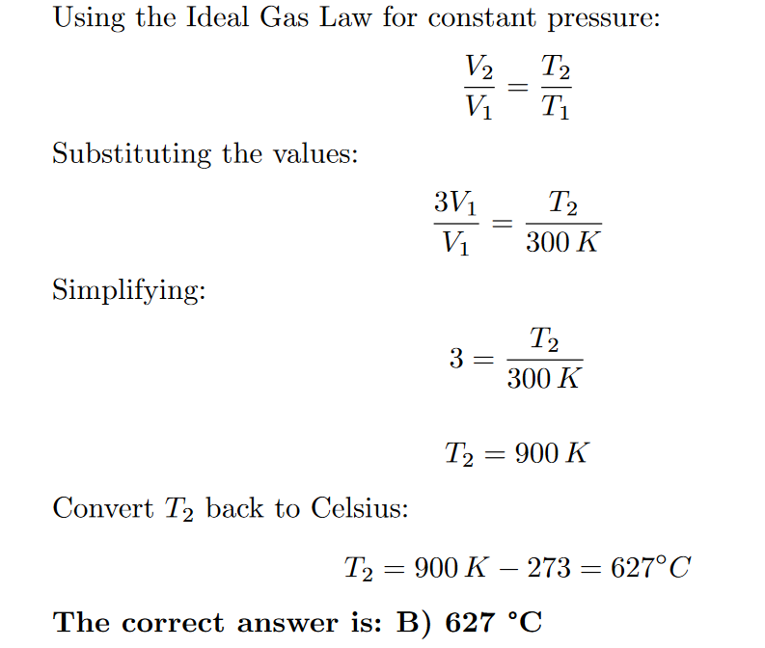

- In a given process of an ideal gas, 𝛿W = 0 and 𝛿Q < 0
- The temperature will decrease
ANS: A
- The volume will increase
- The pressure will remain constant
- The temperature will increase
- None of the above

Explanation:
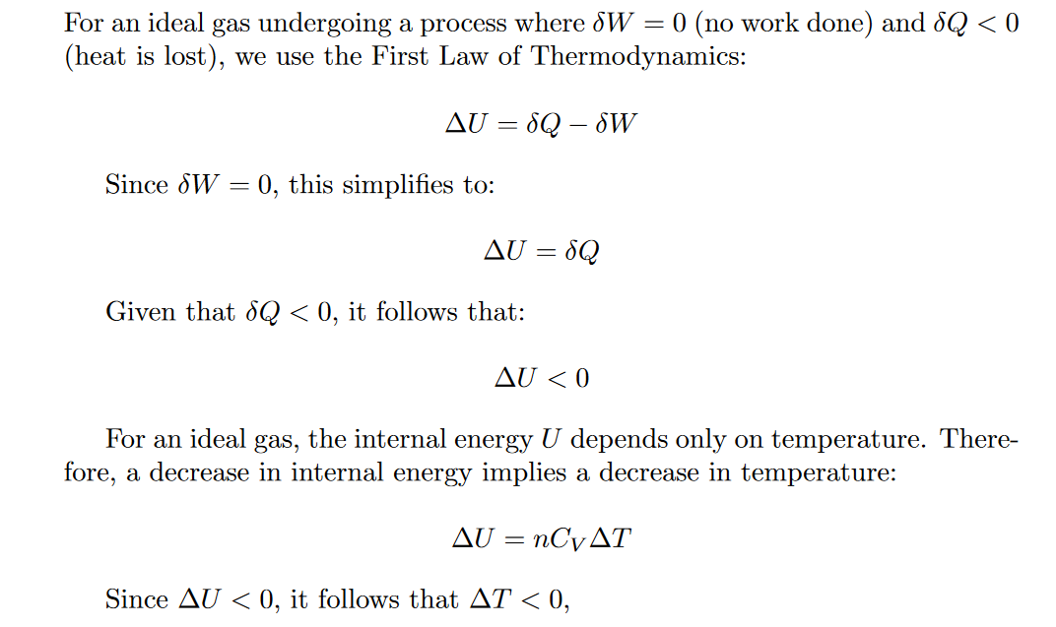

- Two blocks which are at different states are brought together into contact with each other and allowed to reach the final state of thermal equilibrium. The final temperature is specified by
- Zeroth law of thermodynamics
ANS: A
- First law of thermodynamics
- Second law of thermodynamics
- Law of conservation of mass
- None of the above

Explanation:
The final temperature of the two blocks reaching thermal equilibrium is specified by the Zeroth law of thermodynamics. This law states that if two systems are each in thermal equilibrium with a third system, then they are in thermal equilibrium with each other. This principle underpins the concept of temperature and allows us to determine the final temperature when two objects come into contact and reach equilibrium.
So, the correct answer is A) Zeroth law of thermodynamics

- When the pressure of a system is increased adiabatically. Which of the following is correct?
- Temperature remains constant
ANS: C
- Temperature will decrease
- Temperature will increase
- Insufficient information to determine the path of temperature
- None of the above

Explanation:
In an adiabatic process, there is no heat exchange with the surroundings. For an ideal gas undergoing an adiabatic process, if the pressure of the system is increased, the temperature will also increase. This is because, in an adiabatic process, the work done on the system results in an increase in internal energy, which translates to an increase in temperature.
So, the correct answer is C) Temperature will increase

